Final project report UF Europe

Michael Baumgärtner
Munich, Germany
mbaumbartner@ufl.edu

Ignacio Gómez
Madrid, Spain
igomezfernandez@ufl.edu

Hugo Chapado
Madrid, Spain
hugochapado@ufl.edu

Gonzalo Prats
Madrid, Spain
g.prats@ufl.edu

Abstract—This electronic document is a “live” template and already defines the components of your paper [title, text, heads, etc.] in its style sheet. *CRITICAL: Do Not Use Symbols, Special Characters, Footnotes, or Math in Paper Title or Abstract. (Abstract)
Keywords—component, formatting, style, styling, insert (key words)

Introduction (Heading 1)
Introduction. Overview of your experiment/s and a literature review.
For the literature review, include any references to any relevant papers
for your experiment/s. So, whatever you decide to do, search the ACM
and IEEE (or other) literature for relevant papers to read and refer
to.

Implementation
We started the implementation of the project by obtaining the data from (‘data_train.npy’) and the labels from ‘labels_train.npy’), and after converting the data to the proper format we needed to use Tensorflow, we did some preprocessing, where we divided the data into 80% train and 20% validation. As we mentioned before, the whole project development was based on trial and error, so we tried different batch sizes to see which one works better, which is basically the number of samples we processed before we update the model, and we end up choosing the value 32.
One of our goals on the Neural Network was to generalize it, so we tried using random rotations and zooms, so the Neural Network has more images to build up on them. Additionally, we also implemented a dropout, so, every iteration the Neural Network selects random neurons that are ignored during training.
For the Neural Network we build a sequential model with the ReLU (Rectified Linear Unit) activation function . This Activation function has the advantage that it does not activate all the neurons at the same time, which means that the neurons will only be deactivated if the output of the linear transformation is less than 0, what made it the activation function with the best results. The Neural Network has 6 layers, in each of the layers we first perform a MaxPool which helps to reduce the overfitting and spatial size of the convolved features, then we do the dropout we commented before, and finally we perform a Batch Normalization for stabilizing the learning process and reducing the number of training epochs required to train deep networks. We also implemented an additional layer that Flattens and Denses the Neural Network. Flatting a tensor means to remove all the dimensions except for one, so then we input that 1-dimensional array to the next layer. With the use of Flatten we create a fully connected layer because it is connected to the final classification model.
We know that the choice of optimization algorithm can mean the difference between good and bad results, therefore we tried different ones being Adam optimizer with SparseCategoricalCrossentropy for the loss function the one we end up choosing. Adam optimization algorithm has a lot of benefits, being computationally efficient with little memory request. Then, SparseCategoricalCrossentropy is very good when doing multi-class classification because it compares the predicted label and the true label and calculates the loss.

Experiments

Firsts thoughts
During the development of the project, we had to consider what would be the best approach to our problem. This being, the abililty to correctly recognize a high percentage of the validation set of pictures. To do that, we would have to choose among different algorithms the one that fit our data better. The nature and variety of the set of images forced us to use Deep Learning as our approach. Any other non deep learning or linear models were extremely biased by how the images were ordered or rotated and, hence, the success rate was very low. We also considered how much support there is for deep learning algorithms in python (in terms of libraries and functions), so that we could archieve the desired outputs without having to build the entire models from scratch. Apart from that, we should also distinguish between the two approaches we took. First, as described earlier,we used a framework to build a neural network ourselves but then, in the search for more accurate outputs, we adapted a pretrained convolutional neural network, ResNet50, which offered a higher percentage of success. These two will be discussed in the following sections

Frameworks discussion
Before going into the framework discussion itself, it should also be mentioned that one fundamental part of our experimenting was the scaling and rotation of the images, looking for an unbiased model. We noticed that the images were not always representative of the class they belonged to so we needed for the extracted features to be as general as possible so that outliers would not affect the result. The model selected would need the data set to be as generlaized as possible, and in some of the samples, their class was not as clear even for us to decide. By rotating and scaling randomly the images we were able to fix that problem. For example, if the image was a stadium but the actual building was on the right side of the image (being the left just grass or other buildings), then the NN (neural network) would not be able to decide upon just one class (it could just randomly select between the “Building” or “Stadium” classes). However, thanks to this technique, the algorithm was able to learn what a stadium is in a more abstract way, getting rid of biases and outliers.
After looking into possible models for our neural network, our two final proposals were PyTorch and Tensorflow. Both these frameworks, however, cannot directly process images and start working on the model, for that we would have to make the most out of preprocessing. To do that we first had to investigate tensors and their properties, as these are the basic structure to store the data we want to work with. For the reader to follow with our reasoning, a tensor is a data structure used to encode the data we want to process or use. Their structure is like arrays and matrices, but it could be more accurately defined as a multidimensional array, which is what we were looking for in terms of features. They are considered a generalization of most of the other data structures, but they have an interesting property which is: when a tensor modifies all the others in a certain structure, we can keep track of those changes the same way we would modify a vector and then save the changes in a sepparate matrix for later use. This whole structure is what is called a tensor.
Now we can move on to our first choice, PyTorch. It is a very fast and intuitive framework that is also supported by Python, which makes it the most suitable for experimenting. Pytorch offers a complete machine learning package which includes deep learning primitives such as a neural network layer or node structures, activation and loss functions and optimization algorithms to help the user build a deep learning model with basic python programming. Another advantage for this framework is that the graphs are dinamically built along with coding, which again, makes it faster to draw conclusions. For all these reasons, Pytorch was one of the top contenders to use in our final model.
While trying to build our model with this framework, we ran into two problems. First, the dimensionality of the problem was something to consider and, working with several layers of neural networks makes features and their weights more confusing than usual. To maintain coherence between the layers of the NN we should have been able to keep track of how the dimension of each layer would change. Second, to properly manage the whole dataset, we would need an iterator or at least a data structure that worked as such and traverse the whole list of items. For that, pytorch offers DataLoader, which turned out to be not as easy to manage as we would have expected. Then, after several failed attepmts of compilation we decided to abandon this path and try with another framework to see if we could manage it better.
Tensorflow was the other reasonable alternative. Compared to Pytorch, this framework is a lower level of programming which has its advantages and disadvantages. On the one hand, it provides a very flexible toolset for the development of models as lower-level programming languages tend to do. Because of that, the spectrum of experimentation widens and allows the user to get more detail on how to tune the parameters and the possible outcomes that they might have. Another advantage was it supports keras, a deep learning API that helps with the implementation of all the NN functions in a very simple way. On the other hand, learning how to use this model gets more complicated than Pytorch as there are more variables and expressions to learn. This is directly connected to debugging, which was a key stage of our project. This framework is also known for being slower than Pytorch but thanks to UF’s HiPerGator, time management was not really a problem.
To conclude this section, some of the reasons we chose Tensorflow over Pytorch were the following.
- Tensorflow is a much more flexible framework and offers more direct manipulation of the code
- Although Pytorch offers dynamic graphs (with Tensorflow we are not able to modify graphs dinamically), that was not really a need as we did not have to deal with variable length features/inputs
- Learning occurs much faster with Tensorflow with the right parameters. So, if we learned how to use it, it became an advantage
- Following the last point, Tensorflow, was developed and supported by Google, which means that it has a big community behind that can solve doubts almost instantly. Pytorch, on the other hand, is newer and we noticed that when looking for answers to our problems online
- For the same reason, Tensorflow has many resources as to how to use its features, which eased our way in a major way

Implementation discussion
Then into the implementation itself, we had to choose how to design the neural network. In it, through trial and error we concluded that the best number of layers was six. When using less layers, we observed that the outputs were rather random and was highly biased, so it was not a reliable model if we wanted to extrapolate the results. This translates to the model recognizing different objects as the same such as buildings and stadiums or flowers and forests. Then, when using more layers (more neurons), we ended up with an overfitted model that was very sensitive to the outliers and small variations in the pictures we talked about earlier. Again, the accuracy of the model was very low as the outcomes of the model were random. Finally, for the batch sizes we tried different ones until we ended up with the correct one. The effect on having less or more samples per training cycle (batch size) was like the one explained earlier with the different number of layers, with the bias-variance trade-off being the main issue.

ResNet50
The implementation just explained gave us an accuracy of 75-80%, which was far from optimal. That made us think about what other algorithms or approaches we could investigate. Pre-trained models were the best option. These are models that were developed by a third party on a much larger scale (in terms of the dataset) that solve a similar problem to the one we are working on. The idea behind our work was to adapt the model that already existed to the parameters and specific guidelines of the project. This technique is called transfer learning and is widely used in Deep Learning and more specifically, in natural language or tasks processing. With it, we were able to benefit from the enormous datasets that exist nowadays and the algorithms that the community was able to train thanks to them.
One of the most famous pre-trained models in the world of image classification is ResNet50. This is a convolutional neural network made of 50 layers and is part of a larger group of NN called residual neural networks (its name comes from there). The main difference with the rest of the models is that this one stacks the residuals of learning as it goes through the layers as seen in “Fig. 1”, making it more accurate. Going back to the NN in question, ResNet50 was created by Kaiming He and three other computer scientists to participate in the 2015 ImageNet competition. The model won the contest, and they were able to show the world that deeper NN could be trained with accuracy as well. Their work showed a 3.57% error, which is rather small considering that the dataset offered by ImageNet has over 20,000 classes with more than 14 million images in total. Their paper in network architecture was very important for the development of these kind of deep learning algorithms.
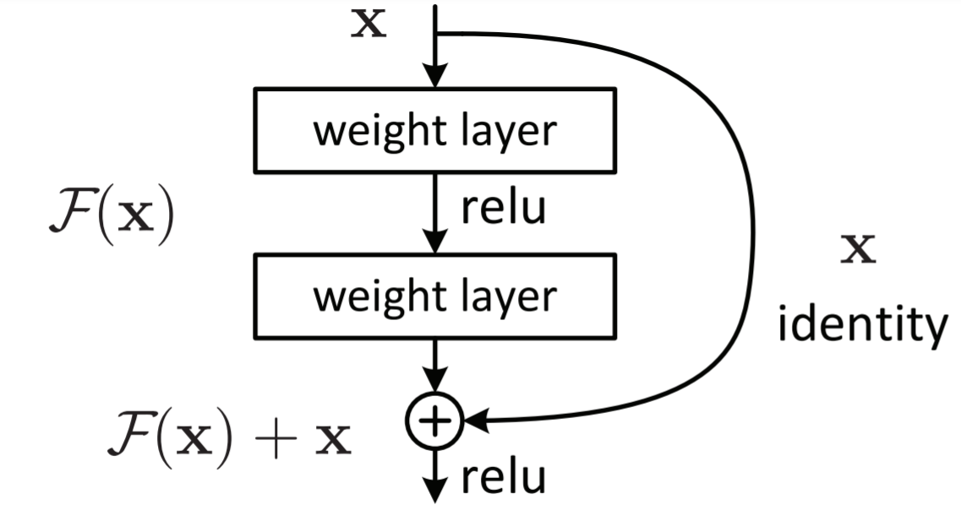

The experimenting phase here was not as intense as when we builded the model ourselves as most of the parameters are set for us. We had to change some of them for the model to work properly. Batch size and random rotations and zooms values stayed the same, we did not feel the need to change them for better results. However, the image size was changed from 300x300 to 224x224 (the algorithm requires that size) and we changed the dropout factor from 0.3 to 0.24. If we want to archieve generalization, the dropout factor should go higher, but we found out that for that value, the results were not as accurate, so we had to perfom a generalization-accuracy tradeoff and ended up lowering that value by a few points. Finally, the number of epochs was significantly reduced as this new algorithm learned much faster (pre-trained) and we would need less iterations to archieve an optimal result. About the epochs, as it can be seen in the figures displayed in the Code, even if we increase the number of them, we will not get much better results than that (or even worse), since the learning curve flattens and there is no room for improvement there. After some trials, we determined that the optimal number of epochs for this algorithm was 40.

Experimenting conclusions
To end this section, the whole project development was based on trial and error. Neural Netwoks are a very complicated structure so trying to understand how they work was the most difficult part. Luckily, nowadays we can find frameworks such as Tensorflow or Pytorch and pre-trained algorithms that allow us to test different parameters, layers, and models with very simple programming. That was the philosophy we followed, to test a set of parameters and, when observing unwanted results (low accuracy), we would analyze the output, figure out why it was like that and change the parameters accordingly.

Fig. 1. Residual learning

